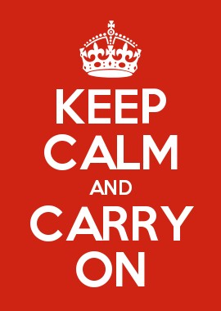
America’s Mottos Assignment Description:
Oceania’s Mottos:
War is Peace
Freedom is Slavery
Ignorance is Strength

You are going to come up with a motto for current American society. This can be something positive or negative. It is essentially a slogan that you think encompasses the beliefs and values of Americans. It is something that you think the majority of Americans live and stand by. It can be a couple of words or it can be a sentence, it’s up to you.
Take this motto and present it as an appealing advertisement. It can be on a small or large scale. You can use images if you would like. If it were hanging up on the wall it should grab my attention and get me to read what it says.
I know this is broad but I want you to take some creative license.
Due: 9/12 & 9/13
America’s Mottos Assignment Description:
Oceania’s Mottos:
War is Peace
Freedom is Slavery
Ignorance is Strength

You are going to come up with a motto for current American society. This can be something positive or negative. It is essentially a slogan that you think encompasses the beliefs and values of Americans. It is something that you think the majority of Americans live and stand by. It can be a couple of words or it can be a sentence, it’s up to you.
Take this motto and present it as an appealing advertisement. It can be on a small or large scale. You can use images if you would like. If it were hanging up on the wall it should grab my attention and get me to read what it says.
I know this is broad but I want you to take some creative license.
Due: 9/12 & 9/13

